# Lab 5:

Name: M Yaqoob

Class: IT-3A

ID: BIT-23F-013

Q1. Print Numbers with Loops: Write a program that uses a loop to print numbers from 1 to 10.

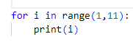

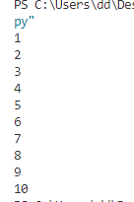

Q2.Calculate the Sum of Numbers: Write a function that calculates the sum of all numbers up to a given number using a loop.

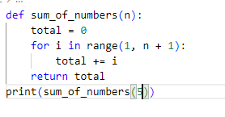

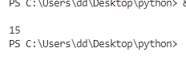

Q3:Display a Star Pattern: Write code using loops and nested loops to create star pattern(discussed previously).

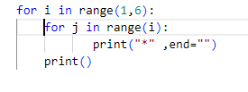 n

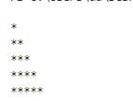

Q4.Find Even Numbers in a List: Write a function that takes a list of numbers and prints only the even numbers.

